* **Lab Task 6:**

### Display Flight Duration, Ticket Price by Country and Airline

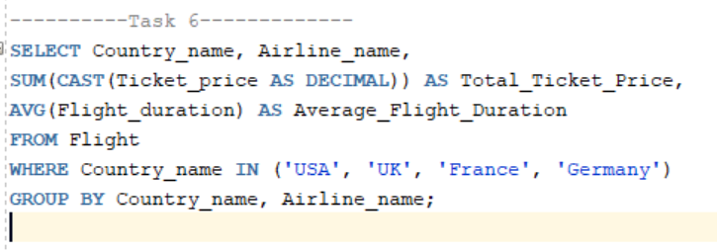

Output:

